Problem statement :

-Subsidy Inc. delivers subsidies to individuals based on their income.

-Accurate income data is one of the hardest piece of data to obtain across the world.

-Subsidy Inc. has obtained a large data set of authenticated data on individual income, demographic parameters, and A few financial parameters.

-**Subsidy Inc. wishes us to :** Develop an income classifier system for individuals.

The objective is to:

Simplify the data system by reducing the number of variables to be studied, without sacrificing too much of accuracy. Such a system would help Subsidy Inc. in planning subsidy outlay, monitoring and preventing misuse .

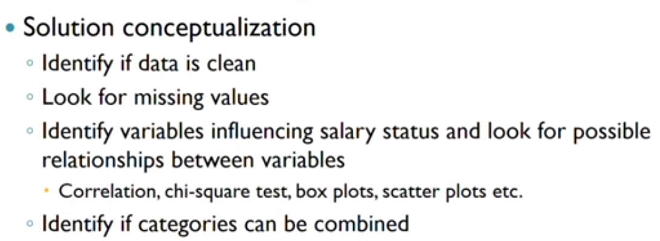

FLOWCHART